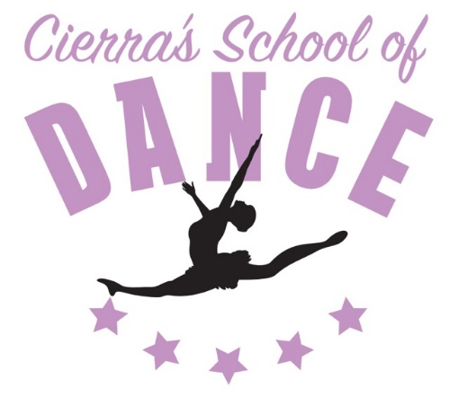
Cierra’s School of Dance
658 N. Independence Blvd.
Romeoville, IL 60446
Cierra Falbo, Artistic Instructor/Director
Tina Falbo, Manager: 630-696-0520

Student’s Name: _________________________________________ Date: ________________
Age: _______ Date of Birth: ___________________
Parents Name(s): ______________________________________________________________
Address: _____________________________________________________________________
City: _____________________________ State/Zip: ________________________________
Phone: __________________________ E-mail: ___________________________________
Emergency Contact/Number (other than parent): _________________________________
______________________________________________________________________________
Does your child have any allergies or medical concerns?___________________________
______________________________________________________________________________

Class | Day | Time | No. of Classes
CSOD accepts Visa/Mastercard; Cash; Checks; Online payment; Chase Quickpay and Zelle.  Make checks payable to: Cierra Falbo | Number of Weekly Classes
 | Tuition
 | Any Applicable Discounts
 | Total Due

Studio Rules:
- Be timely. Attendance is taken in every class.
- Parents, family members, and other students (not enrolled in that class) may NOT be in the dance studio during classes. This is a closed door policy. Anybody is welcome to wait in the lobby.
- There is NO gum chewing, food or drinks, other than water allowed in the dance studio.
- Dancers must arrive in their required dance attire and be ready prior to the class starting. Dancers not following dress code will not participate in class.
- Dancers are to respect all peers, instructors, staff and Cierra's School of Dance, hereinafter referred to as ("CSOD") clientele. We like to maintain a dance studio family feel. The dance studio is a place to encourage, cheer on, and make friends while doing what you love.
- Parents are responsible for any damage done by their children.
- CSOD is not responsible for any lost, misplaced or stolen items. Feel free to label your dancer's bag, shoes, etc.
- Any dancers with cell phones are to leave them in the OFF or SILENT setting throughout their classes. Cell phones are to be kept in their dance bags.
- Street shoes are NOT allowed to be worn on the dance floor.
- Every dancer or family has a mailbox which notices will be handed out in. Make sure your dancer takes home whatever is in their mailbox after each class.
- Snacks are for sale as well as water bottles from our fridge ($1 each) in the lobby. Please send your dancers with money just in case.
- Every family has an account at CSOD. If you would like to put money into your account for future use (i.e.: water, snacks, shop purchases, tuition, costumes, etc.) you may do so at any time.
- Certain classes have other class requirements to be taken alongside. This is mandatory and is for the safety and benefit of your dancer.

This form must be signed in order for any student to participate in classes

In attending CSOD, taking dance classes and otherwise using the facilities and equipment therein, I do so at my own risk. Neither Cierra Falbo nor any other faculty members of CSOD shall be liable for any damages arising from personal injuries incurred by me, in, on, or about the premises relative to my attendance. I assume full responsibility for any injuries or damages which may result to me in, on, or about the premises, and I do hereby fully and forever release and discharge CSOD, Cierra Falbo, Tina Falbo, its shareholders, directors, officers, dance instructors, employees, and agents from any and all claims, demands, damages, rights of action or causes of action, present or future, whether the same be known, anticipated or unanticipated, resulting from or arising out of my use of said CSOD, dance classes, facilities, and equipment thereof.

In addition, I understand that correct physical placement and body alignment are necessary in order for all dance movement to be properly executed. I understand and agree that the instructors may have to physically touch my child within a class setting for correction purposes. Finally, I give CSOD, Cierra Falbo and the instructors of CSOD my permission for the use of any printed photographic and/or video recordings of the above named student to be used in any promotional and/or fundraising materials. With this release, I also understand that we will not receive any compensation for the use of said materials.

I agree to pay either in full or in monthly installments. I understand that when I register my child for dance classes at CSOD, there will be no refunds on the registration fees or tuition that is paid in order to hold my dancer(s) spot in their class. I understand that if I pull my dancer out of class, any payments I have made are non-refundable. The only time I am eligible for a refund is if the studio drops a class due to low enrollment; then and only then will I be eligible for a refund for my payments in the form of studio credits. I understand that if my child has any outstanding fees, they will NOT participate in classes or recital and I will owe the appropriate late fees as stated in the handbook.

I have received the CSOD current handbook and agree to adhere to all the contents stated therein. This includes, but is not limited to, payments, dress code, etc.

I hereby acknowledge that I have read and agree with the above information as it pertains to the student listed above.

Signature of parent or legal guardian: ______________________________________________________________________

Printed Name: ____________________________________________________________________ Date: ________________

Student’s signature (if over the age of 18): __________________________________________________________________

